Development of a Raspberry Pi-Powered OCR Text Detection and English-Tagalog Translation System
CPE179P_E01 — AI on the Edge with Huawei Ascend and Atlas

Group 1
Estilo, Cristel Anthonette S. – 2023104303
Ngo, Justin Chandler K. – 2021130120
Pagala, Denise Kate L. – 2023101490

Submitted to Engr. Dionis A. Padilla
September 2026

1.0 Executive Summary

This project proposes the development of a Raspberry Pi 4B-based system that captures an image of printed English text, extracts the text using Optical Character Recognition (OCR), and translates it into Tagalog. A USB webcam will be used for image capture, while the Raspberry Pi 4B will handle image processing, OCR, and translation. The system will process still images instead of continuously recognizing text from a live camera feed, and the extracted English text together with its Tagalog translation will be displayed through a graphical user interface. The project aims to provide a simple and convenient way of translating printed English materials without requiring users to manually type the text into a separate translation application.

2.0 Introduction

English and Tagalog are widely used in the Philippines and play an important role in everyday communication and in accessing information, particularly in documents, learning resources, and other texts. Digital translation tools make the process easier when the text is available in digital form. However, translating information from printed documents can be more time-consuming. Users may have to read the documents, manually type or copy the text, open a translation tool, choose appropriate languages, and then obtain the translated result. These additional steps can make the translation process less convenient and efficient.
This presents an opportunity to automate the process by capturing the physical documents containing text and converting their contents into machine-readable text through Optical Character Recognition (OCR). The extracted text can then be processed and translated automatically, reducing the need for manual transcription. The recognized text will be translated between English and Tagalog depending on the selected language to translate. Moreover, the project will utilize the Raspberry Pi 4 as the edge computing device and a web camera to capture the documents. The integration of OCR, language translation, and edge computing aims to provide a streamlined process for converting physical text into its translated digital form.

3.0 Background of the Study

Optical Character Recognition is a technology used to transform text contained in an image into machine-readable characters. Instead of requiring users to manually reproduce the contents of a physical document, an OCR system analyzes the image and identifies the characters and words that appear within it. Tesseract is one example of an open-source OCR engine designed for text recognition and has been developed for the recognition of printed text from digital images.

The quality of an OCR result can be affected by the quality of its input image. Factors such as illumination, image blur, orientation, contrast, and text size may influence whether individual characters are recognized correctly. Image preprocessing can therefore be performed before OCR. Operations such as grayscale conversion and thresholding can make the difference between the foreground text and its background more distinguishable. OpenCV, for example, provides thresholding techniques that can be applied to grayscale images before subsequent image analysis.

4.0 Problem Statement

Despite the widespread use of English and Tagalog in the Philippines, translating information from physical documents can still require manual text entry or multiple processing steps. This additional step can make the translation process less convenient, particularly when dealing with printed materials containing multiple words or sentences. Furthermore, traditional translation workflows treat text capture and translation as separate processes, requiring users to capture the document and open a website/ application that can translate the document.

5.0 Objectives

General Objective
This project aims to develop an Edge-AI based English-Tagalog translation system that captures text from physical documents, identifies and extracts the text through Optical Character Recognition (OCR), and translates the recognized English text into Tagalog using Raspberry Pi 4 and USB camera.

Specific Objectives
The project specifically aims to:
- Develop an OCR-based software that can identify and extract printed English text from captured images of physical documents
- Develop a user-interface that allows the user to capture printed English text and display the corresponding Tagalog translation
- Implement a USB camera for capturing images and Raspberry Pi 4 as the edge computing device for processing the captured images
- Implement an English-to-Tagalog machine translation model for translating the recognized English text
- Evaluate the system using a dataset consisting of 100 images of printed English text

6.0 Significance of the Project

The proposed project will utilize the integration of Optical Character Recognition (OCR), machine translation, and Edge AI to automate the process of translating text from physical documents. The system will combine the following functions, image capture, text recognition, and translation, to reduce the need for manual transcription and provide a more streamlined approach to processing printed information. Furthermore, one of the target users of the project will be the students and learners as the system may assist students in translating printed education materials, notes, and other learning resources instead of manually typing the text into a translation tool. General users can also benefit from this project as it will provide a convenient method for translating English and Tagalog text found in physical documents. Lastly, the project can also be used by future researchers as it demonstrates the practical integration of OCR, machine translation, Raspberry Pi 4, and camera-based image acquisition within an Edge AI environment.

7.0 Scope and Limitations

Scope
The scope of the project will cover the following:
- Image Acquisition - The project will utilize a USB camera to capture images of physical paper documents
- Optical Character Recognition - The project will implement OCR to identify and extract printed English and Tagalog text from captured images
- Language Selection: English & Tagalog - The user can select English or Tagalog as the source language, while the system automatically assigns the other language as the target language
- User Interface - The project will include a user interface to display the captured image and translated output
- Machine Translation - The project will translate the recognized text between English and Tagalog using a machine learning-based translation model
- Edge AI Deployment - The project will utilize a Raspberry Pi 4, ONNX Runtime, FastAPI, and REST API for the deployment and communication of the system
- Dataset - The project will utilize 100 images of printed English text selected from the Phitran21 synthetic OCR dataset for system development and evaluation
- Text Length - The system will process a maximum of 100 words per captured image

Limitations
The project will be limited to the following:
- Language - The system will only support English and Tagalog translation
- Text Type - The system will be limited to printed text only and will not include handwritten text
- Image Conditions - The captured images should contain clearly visible printed text with sufficient lighting for OCR processing
- Text Length - The system will only process a maximum of 100 words per captured image
- Dataset Size - The dataset used for system development and evaluation will be limited to 100 images
- Translation Direction - The system will only support English-to-Tagalog translation

8.0 Review of Related Technologies & Studies

Optical Character Recognition (OCR) plays an important role in converting printed documents into editable and machine-readable text. Li et al. (2025) developed a printed-document recognition system that combines document layout analysis with deep-learning-based text recognition, showing how OCR can identify and organize different parts of a document before producing editable output. OCR performance, however, still depends on several processing stages. Avyodri et al. (2022) described OCR as a process involving image preprocessing, text localization or segmentation, feature extraction, recognition, and post-processing, while also noting that OCR does not always achieve perfect recognition accuracy. This makes image preparation especially important for the proposed system, since the input will come from images captured using a webcam. Singh et al. (2025) demonstrated the use of OpenCV-based preprocessing to improve image clarity and make textual information easier to extract, while Maliński and Okarma (2023) further showed that preprocessing methods such as filtering, contrast enhancement, scaling, straightening, and binarization can influence OCR performance, particularly when lighting conditions vary. These studies support the inclusion of an image-processing stage before OCR in the proposed system so that the captured English text can be made clearer before recognition.
Text recognition also becomes more challenging when the input is obtained from a camera rather than a clean scanned document. Pal et al. (2024) reviewed text detection and recognition in natural scene images and discussed difficulties such as varying text orientation, shape, and surrounding visual conditions. Although the proposed project will focus on printed documents under more controlled conditions, these challenges remain relevant because the image will still be captured through a camera and may be affected by positioning, lighting, or image quality. Once the English text is successfully extracted, the next stage of the system involves machine translation. Macayan et al. (2026) explored neural machine translation involving Filipino in an ultra-low-resource setting and found that techniques such as transfer learning and synthetic data could improve translation quality when language resources are limited. Their work highlights the challenges of developing translation systems that involve Filipino and shows the potential of neural machine translation for local-language applications, which is relevant to the English-to-Tagalog translation component of the proposed project.
The choice of the Raspberry Pi as the main processing device is also supported by recent work involving AI deployment on edge-computing platforms. Al Dahoud et al. (2026) presented a Raspberry Pi CM5-based platform capable of supporting several AI functions, including computer vision, natural language processing, and machine learning, demonstrating how compact computing devices can be used for AI-related applications. A more closely related implementation was presented by Vasanth and Kumar (2025), who deployed a multi-stage AI pipeline on a Raspberry Pi 4 that included OCR, text correction, and text-to-speech processing. Their study showed that several AI tasks can be combined and executed on a resource-limited edge device, although they also noted the need for further evaluation using larger datasets. This supports the proposed project's use of the Raspberry Pi 4B to handle image processing, OCR, and English-to-Tagalog translation within one system rather than relying on a separate desktop computer for each processing stage.

9.0 Methodology

Hardware Development
The primary hardware components will consist of a RaspberryPi 4B as the main processing device and a USB webcam to capture the images of the texts to be translated. The camera will be positioned so the text can be placed or held to be captured by the system.

The Raspberry Pi 4B will be responsible for receiving the captured image and running the necessary processing tasks of the system. These include image preprocessing, text extraction through Optical Character Recognition (OCR), and English-to-Tagalog translation. The USB webcam will only capture a still image when initiated by the user, rather than continuously processing text from a live video feed.

Software Development

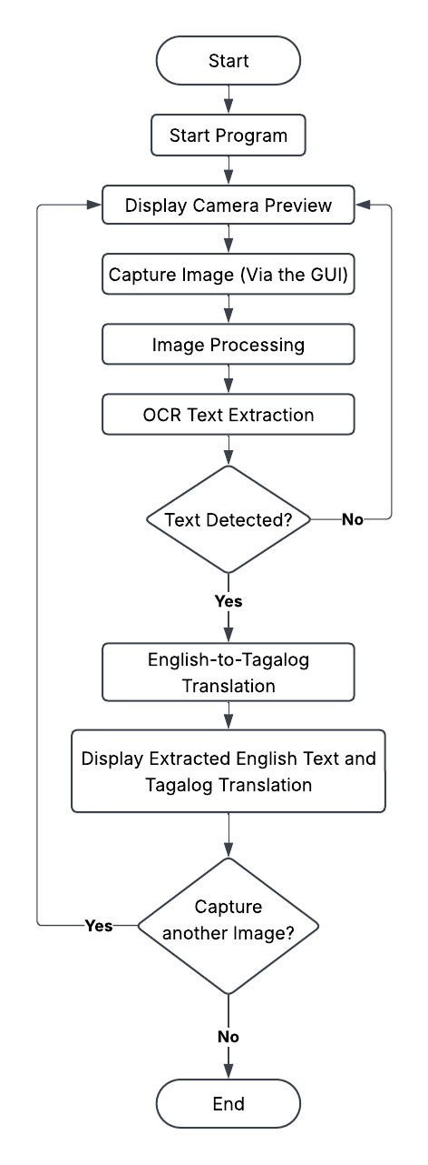
Figure 9.1: Software Development Flowchart

The software development is presented by Figure 9.1 where once the program starts, the system will display the camera preview through the graphical user interface (GUI), allowing the user to properly position the printed English text before capturing an image. After the image is captured, it will undergo image processing to improve its quality and make the text more suitable for Optical Character Recognition (OCR). The OCR process will then extract the English text from the captured image. If no text is detected, the system will return to the camera preview so the user can capture another image. If text is successfully detected, the extracted English text will be processed by the English-to-Tagalog translation model. The recognized English text and its corresponding Tagalog translation will then be displayed through the GUI. After viewing the results, the user may choose to capture another image, which will return the system to the camera preview, or end the program.

Use Case Diagram
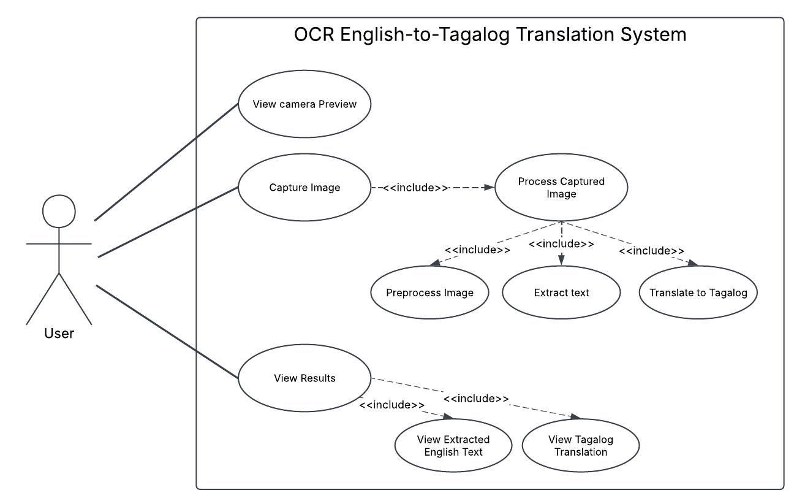
Figure 9.2: Use Case Diagram

The use case diagram shows the interactions between the user and the proposed OCR English-to-Tagalog translation system. The user can access the camera preview, capture an image of printed English text, initiate the processing of the captured image, and view the extracted English text together with its Tagalog translation.

10.0 Expected Deliverables

At the completion of the project, our group expects to produce the following deliverables:

- Functional Raspberry Pi-Based Prototype - A working Raspberry Pi 4 system connected to a USB camera and capable of processing captured document images.
- Text Image Capture Module - A software component that allows the user to capture a single image of a printed English document for processing.
- Image Preprocessing Module - A component responsible for preparing captured images before OCR through appropriate image-processing techniques.
- OCR Module - A functioning OCR component capable of extracting printed English text from captured images.
- English-to-Tagalog Translation Module - An integrated machine translation component capable of converting recognized English text into Tagalog.
- User Interface - An interface displaying the captured document image, detected English
- Performance Evaluation Results - Documentation of OCR accuracy, translation evaluation, processing time, and observations obtained during system testing using the 100-image dataset.
- Project Documentation - Technical documentation describing the system architecture, hardware setup, software implementation, testing procedure, results, and identified limitations.

11.0 Conclusion
The proposed system will integrate image capture, image processing, OCR, and English-to-Tagalog translation into a single Raspberry Pi 4B-based application. By processing a captured image of printed English text, the system will be able to extract the text and provide its Tagalog translation through the user interface. Although the project is limited to printed English text, controlled document conditions, and one-way English-to-Tagalog translation, it demonstrates how OCR, machine translation, and edge computing can be combined into a practical and compact translation system.

12.0 References

Al Dahoud, A., Fezari, M., Al Dahoud, A., Al-Zoubi, A. M., & Al-Mimi, H. (2026). Exploring the new edge AI computer based on raspberry pi CM5. Lecture Notes in Networks and Systems, 1–10. https://doi.org/10.1007/978-3-032-27927-9_1
Li, D.-L., Lee, S.-K., & Liu, Y.-T. (2025). Printed document layout analysis and optical character recognition system based on deep learning. Scientific Reports, 15(1). https://doi.org/10.1038/s41598-025-07439-y
Macayan, A. D., Madridijo, L. A. S., Esponilla, E., & Francisco, Z. M. (2026). Tao–Filipino neural machine translation: Strategies for ultra–low-resource settings. Proceedings for the Ninth Workshop on Technologies for Machine Translation of Low Resource Languages (LoResMT 2026), 27–36. https://doi.org/10.18653/v1/2026.loresmt-1.2
Maliński, K., & Okarma, K. (2023). Analysis of image preprocessing and binarization methods for OCR-Based detection and classification of Electronic Integrated Circuit labeling. Electronics, 12(11), 2449. https://doi.org/10.3390/electronics12112449
Pal, U., Halder, A., Shivakumara, P., & Blumenstein, M. (2024). A comprehensive review on text detection and recognition in scene images. Artificial Intelligence and Applications, 2(4), 257–277. https://doi.org/10.47852/bonviewaia42022755
Ridvy Avyodri, Lukas, S., & Hendra Tjahyadi. (2022). Optical character recognition (OCR) for text recognition and its post-processing method: A literature review. https://doi.org/10.1109/ictiia54654.2022.9935961
Singh, K., Aman, S., Kumar, S. A., Prateek, P., & Munzarin, S. (2025). Efficient image preprocessing pipeline for accurate text extraction using OCR and pattern matching. AIP Conf. Proc., 3224(1), 020042. https://doi.org/10.1063/5.0247289
Vasanth, M. V., & Kumar, T. K. (2025). An optimized end-to-end AI pipeline for dyslexia-assistive handwriting analysis on a raspberry PI 4. 2025 International Conference on Computational Intelligence and Knowledge Economy (ICCIKE), 104–108. https://doi.org/10.1109/iccike67021.2025.11318176

Signature Page

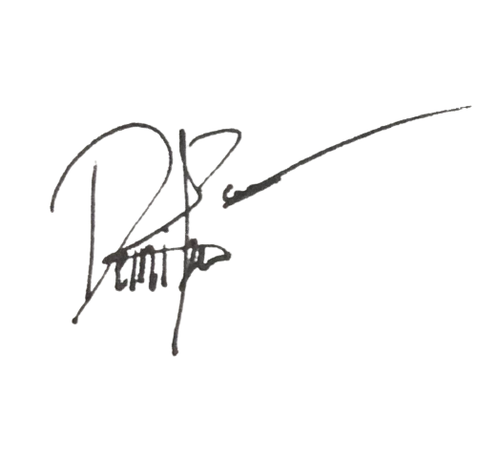


Cristel Anthonette Estilo |  | September 24, 2026
Justin Chandler Ngo |  | September 24, 2026
Denise Kate Pagala |  | September 24, 2026

